**COMP229 – Web Application Development**

Project Part 3 – Frontend - Backend Integration and CRUD Operation.

**Due**: End of Week 12

**Value**: 10%

Second Release

# Overview:

1. Your team is responsible for the second release of your Web Application.
   * Your site must include a **Home/Landing Page** that is appropriate for the type of Web Application you have selected and should include the Name of the Site and your Team’s Logo.
   * Your **Home/Landing** Page should allow the user to **view** an appropriate list of appropriate objects created for the type of site you have selected to build.
   * Your **Home/Landing** Page must include pages that allow your user to SignUp and SignIn.

**NOTE: This is just a sample below as discussed in class.**

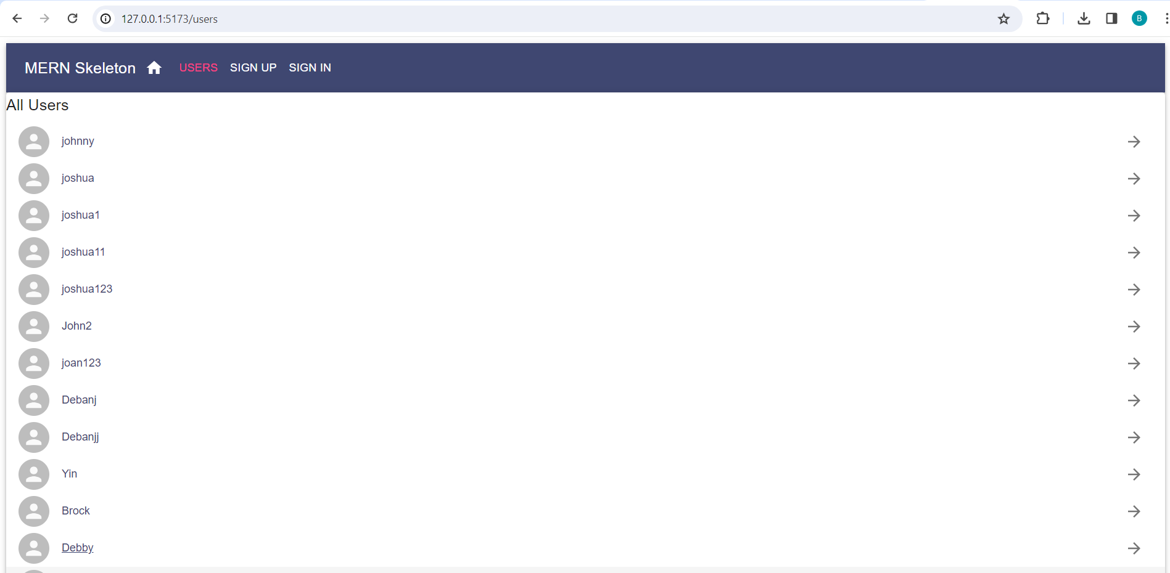

1. You Application must include authenticated Menu/Navigation bar across the frontend application by providing links to all the available views, and also by indicating the user's current location in the application.
   * When the user **is logged in**, the navigation bar should show the users, Myprofile and signout Navigation Item.



* + Your site’s **Main Navigation** must include Navigation Items (or other UI elements) that allow the user to navigate to appropriate pages.

1. Your site should allow the user to perform **full CRUD** (Create, Read, Update and Delete) operations on the type of objects and data relevant to the site you have selected to build.
2. Establish a connection between the React user interface (UI) and the Express CRUD API enabling seamless communication and data transfer between the front-end and back-end of the application
3. Your team must also demonstrate progress towards the final web application project by providing a link to the project's **GitHub repository**. Ensure the repository contains commits from each member of the group. Ensure your project is organized, understandable and named appropriately.
4. You must keep track of your project by using an **Agile Project Management** tool (e.g. Jira, Trello, etc.). Your tracking tool should include a Product Backlog and a Task Board.
5. Create a Short Video presentation on **YouTube** or another streaming provider. You must include a short **PowerPoint** (or Google Slides) Slide Deck that includes **two slides**.
6. The **First Slide** of your Slide Deck must include, your **Team Name**nd **Logo** (developed during Contract creation and Team Formation), the **Full Names** and **Student IDs** of all team members involved in the project, the **Course Code**, **Course Name,** and your **Project** information (which type of project you have selected)
7. The S**econd Slide** of your Slide Deck must include **current images** (mugshots) of each team member (no avatars allowed) that are displayed appropriately on the page. The team member’s **Full Name** and **Role** must appear underneath their image.
8. One or more team members will **demonstrate** your site’s **functionality**. They must showcase each page working properly
9. One or more team members will **briefly describe the code** in your web application that drives the functionality of various features of your site.
10. Sound for your Video must be at an appropriate level so that the voice of any presenter may be **clearly heard,** and the screen resolution should be set so that code and site details are **clearly visible**.
11. Your Short Video should run no more than 5 to 10 minutes.

# Submission Details:

* + A zip archive of your Project Files uploaded to eCentennial. Rar archives **will not** be accepted.
  + An External Design Document (EDD) v.1 (PDF Format)
  + GitHub link to team’s working project repository
  + A link to your Demo video (YouTube preferred).
  + A snapshot of your Project’s current Product Backlog (PDF Format)